Littleneckhalfshell
- Plunderer
- Member

- 390 posts
- Gender:Male
- Location:Hudson Valley, NY
- Interests:Blacksmithing, hunting, fishing, stuff.......
(IP: 68.193.4.238) ·
Posted March 27, 2008 · Report post
was researching period correct tools and came across this "masters thesis"
"Wrought Iron Hand tools in Port Royal, Jamaica: a study based upon a collection of the tools recovered from archaeological excavations and on tools listed in the probate inventories of colonial port royal c. 1692" http://nautarch.tamu.edu/pdf-files/Franklin-MA1992.pdf
did you know that claw hammers are period correct?!
Anyway, does anyone have other books, sites, info on period correct tools?
examples of what I am looking for - you don't want to show up with a 'twist drill', from what I can tell, it would have to be a spoon bit, since twist drills were not invented yet.

- Quote
- Edit

Dutchman
- Has anyone seen my cousin?
- Admin

- 1,773 posts
- Gender:Male
- Location:tidewater virginia
(IP: 165.176.50.253) · ·
Posted March 30, 2008 · Report post
the guru on what you are looking for is roy underhill from the woodright shop. check out PBS-TV, they have a few episodes on line. as well, he has a few great books out. I have been fortunate enough to sit in on a few of his lectures as well. a true gentleaman all the way around.
somewhere packed away is a book on making a basic 18th century hand tool kit. i'll have to find the title for you.
as far as bits go- spoon bits are correct. you also have spade bits and gimlets (i don't think i spelled it right) its like a bullet remover- the cordless drill of its day. and i would like to sort of correct you. twist bits were around, but not as we think of them. a twist bit is nothing more than a threaded rod- admittedly a big, wide, sharp thread. they could not bore the original hole but a graduated series of these will enlarge holes cleanly.
clawed hammers go back to the late 1500's atleast. whats important to remember about early nails (not spikes or brads) is that many were designed to go through the wood and be bent to anchor it in place a pilot hole also had to be drilled for it. you cant do that with a masonry nail, which some folks try to pass off as a reproduction. you will tear your wood to pieces before it bends enough to hold.
measuring- find an old stanley model 64 1/2 folding ruler. its a 24 incher folder thats pretty close. just refinish it and at ten feet you cant tell.
there is a hogarth print that depicts a lumber yard. other than givin the impression that men greeted all women by grabbing their breasts, there are good examples of clothing and tools. anyone happen to have a link??
i have plenty more packed away, need to come to the blackbeard fest and see some of my toys. i don't pull the tools out too often, but if i know someone is coming who is interested, i'll bring more than a basic carpenters box, heck for the right crowd i might pull out the adze and give alesson on amputating toes.. hope this helps.
-dutch

- Quote
- Edit
- Options

Littleneckhalfshell
- Plunderer
- Member

- 390 posts
- Gender:Male
- Location:Hudson Valley, NY
- Interests:Blacksmithing, hunting, fishing, stuff.......
(IP: 68.193.4.238) · ·
Posted March 31, 2008 · Report post
Thanks for the reply. Adze and draw knife I have as well as a lot of 18th and 19th cent. tools
I have a beautiful wood and iron brace with the square socket, a set of gimlet type bits for it as well as a few spoon bits and a lot of twist drills with screw pilots, but from what I can tell, the iron brace is more 19th cent. I could make a good Civil War period kit, but not GAOP. I do some blacksmithing, (have lots of those tools) so I could maybe make anything I needed, but don't have really any good idea of what it should look like. My understanding is that many of the tools in existance in the GAOP 1680-1720 were still in existance in the 18th century, but that their 'style' or 'form' was different, they had 'evolved' if you will. So a 17th cent thing-a-ma-bob will do the same job of a 18th cent. one, but just look different. Just like you recognize a model A as an automobile, but it looks a lot different from a Chevy from the 1950's. I have the Roy Underhill books and a number of other tool related books, but they are often more in tune with the Colonial (Rev.war) to civil war periods. The reason I found the Port Royal info, is that what was sunk there, was the time period I am looking for tools from.

- Quote
- Edit
- Options

Dutchman
- Has anyone seen my cousin?
- Admin

- 1,773 posts
- Gender:Male
- Location:tidewater virginia
(IP: 75.75.123.39) · ·
Posted March 31, 2008 · Report post
ok, not the book i was looking for but find a copy of Tool Making Projects for Joinery and Woodworking by Steve Olesin. lots of make it yourself tools.
sometimes its the little things that separate 17 & 18th century tools. one of my sets of spade bits is early 1800's, but hold them up to period bits and unless you are really looking at the throats they are the same.
i have a period brace and made a copy off of it. other than the chuck set, there are no moving parts. a couple of leather pads provide a little protection for your hands. its a bear but it works.
here's one for you. on period hand saws the front of the blade (not the teeth, the sheet itself) is curved with a notch a few inches back from the end of the blade. whats it for?

- Quote
- Edit
- Options

Littleneckhalfshell
- Plunderer
- Member

- 390 posts
- Gender:Male
- Location:Hudson Valley, NY
- Interests:Blacksmithing, hunting, fishing, stuff.......
(IP: 68.193.4.238) · ·
Posted April 1, 2008 · Report post
(""here's one for you. on period hand saws the front of the blade (not the teeth, the sheet itself) is curved with a notch a few inches back from the end of the blade. whats it for?"")
I don't know, and from what I have read, no one does for sure, some suggest that it is to make the starter notch (slide the smooth back of the saw against a thumb and then when it comes to the end the notch nicks the wood where you want to cut)
Anyway, I have some saws from my grandfather that have that little oddity on the end and I am sure that they are not from the GAOP, my grandfather was not that old
I would be intersted in a picture of your period brace, but what period? my understanding is that the brace, even with integral bit (not removable) was post GAOP I will see if I can post a picture of my antique brace. I have read that though the ones that were all wood with metal side supports are the early pattern for woodworking, that Shipbuilding braces were often made of iron. Just not fully clear on the timeline. That is sort of what I have been looking for in starting this thread, a good timeline, with pictures or drawings, of when various tools came to be.

- Quote
- Edit
- Options

hurricane
- Pyrate Legend
- Member

- 2,672 posts
- Gender:Male
- Location:Seattle, Washington
- Interests:Songs of a nautical nature, wine, rum, rum punch, Henry Morgan and Krimson Kat.
(IP: 68.204.134.42) · ·
Posted April 1, 2008 · Report post
Here's one from the mid to late 1600's from Holme's work.
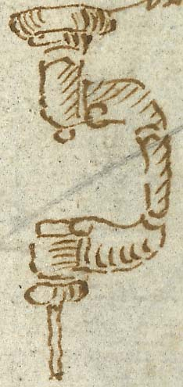
Brace and bit
XXIV. He beareth a Brace and Bit. This hath several denominations as I find amongst Workmen; for of some it is termed a Brace, others a Wimble, others a Wimble Brace, and a Vambrace; in London it is generally termed a Piercer. It is used in Boring of Holes to drive Wooden Pins through Mortesses and Tennants in joyners work.
-- Hurricane

- Quote
- Edit
- Options

JohnnyTarr
- Dread Pyrate
- Member

- 1,082 posts
- Location:Kohler, WI
- Interests:Sailboats, sailing, Geocaching, beer and wine making, cartography, weapon fighting, fiddle.
(IP: 66.190.45.154) · ·
Posted April 1, 2008 · Report post
Found this website. I doubt that it is period but I also doubt that they changed much between then and now. Well you know what I mean.
http://www.vintagetools.net/products.php?c=147

- Quote
- Edit
- Options

Littleneckhalfshell
- Plunderer
- Member

- 390 posts
- Gender:Male
- Location:Hudson Valley, NY
- Interests:Blacksmithing, hunting, fishing, stuff.......
(IP: 68.193.4.238) · ·
Posted April 1, 2008 · Report post
First, thank you Hurricane, for some reason I did not think the brace was period, I guess you can't believe everything you think you read.
Second, JohnnyTar, the pictures of braces you gave a link to are definitly braces, but very modern, the old ones didn't have mechanical chucks, I 'know' (at least I hope I know, I am not doing very well in that realm right now ) that a mechanical chuck is way post period. Here is what I have, now, let me know if I could safely bring it as a carpenter's mate to a historical gathering and pass muster.
Littleneckhalfshell - Photobucket
for those interested further, here is a closeup of the chuck (dual for flat taper and pyramid taper) and a close up of the spoon bit with a flat taper.
http://i175.photobucket.com/albums/w132/li...vstwistbits.jpg
http://i175.photobucket.com/albums/w132/li...l/dualchuck.jpg
Also note that I have included some long borers that I think may not be period, the ones with the screw leads I feel definitly are not, but what of the one with out the screw lead? Also in the first posted picture, note the gimlet style bits, star bit, and is that one a 'spade bit' possibly?

- Quote
- Edit
- Options

Littleneckhalfshell
- Plunderer
- Member

- 390 posts
- Gender:Male
- Location:Hudson Valley, NY
- Interests:Blacksmithing, hunting, fishing, stuff.......
(IP: 68.193.4.238) · ·
Posted April 1, 2008 · Report post
Ok, lets try this again....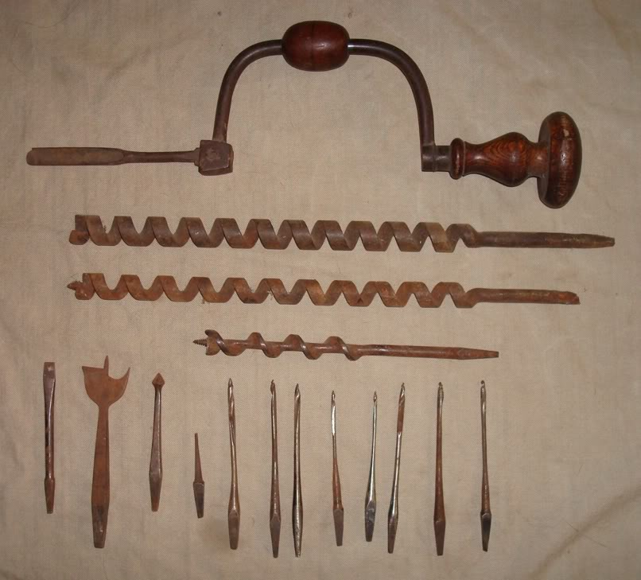

- Quote
- Edit
- Options

Silver
- Plunderer
- Member

- 347 posts
- Gender:Male
- Location:Virginia Beach, Virginia
- Interests:Maritime history
(IP: 24.253.129.208) · ·
Posted April 1, 2008 · Report post
i have the same brace. i got mine in a junk shop where did you run across your's?

- Quote
- Edit
- Options

Littleneckhalfshell
- Plunderer
- Member

- 390 posts
- Gender:Male
- Location:Hudson Valley, NY
- Interests:Blacksmithing, hunting, fishing, stuff.......
(IP: 68.193.4.238) · ·
Posted April 1, 2008 · Report post
The sister of a lady at my church was moving to a retirement community, her husband was a guy who had a lot of tools and after the yard sale, there was still a lot left over. The lady from my church knew that I was interested in tools of any kind, so she sent me over to her sister. I walked away with three milk crates full for free. The brace and the bits were part of the haul.

- Quote
- Edit
- Options

Dutchman
- Has anyone seen my cousin?
- Admin

- 1,773 posts
- Gender:Male
- Location:tidewater virginia
(IP: 75.75.123.39) · ·
Posted April 2, 2008 · Report post
and the official answer to the dohicky notch on the saw- straight from roy underhill himself...... to mess with our minds centuries later! no one knows.
sorry im a cynical bugger- couldn't help myself.
anyhow onto the bit and brace. i have heard reference to the egyptians. i cannot confirm that one. personally i can only verify to the 1500's.
the brace is mid 1800's at best, i've got one with nice maple furniture.
to the bits.. looks like an interesting mix.
the three threaded bits are definitely not our period, but are interesting. the top two have no center shaft and the socket end is pretty eaten. you really can't tell a whole lot. does it have any markings?
the bottom is recent. the outer edge of the thread is narrow and curves where it meets the shaft as opposed to a sharp angle.
all of the bits (except the srew) look good. there is a nice mix. notice on your spade the short throats from the tip i was talking about. GAOP would be longer running about 1/4 the length of the bit gradually , not sharp.
from left to right on the bits. #7 & #10- do they have markings- in particular single letters. not like a set of owners initials- but a single capitol leter? they should be different letters.

- Quote
- Edit
- Options

Littleneckhalfshell
- Plunderer
- Member

- 390 posts
- Gender:Male
- Location:Hudson Valley, NY
- Interests:Blacksmithing, hunting, fishing, stuff.......
(IP: 68.193.4.238) · ·
Posted April 2, 2008 · Report post
bbcddutchman, you said earlier in the thread ""i have a period brace and made a copy off of it. other than the chuck set, there are no moving parts. a couple of leather pads provide a little protection for your hands. its a bear but it works.""
could you post a picture of the period brace and the copy? I would like to see what I should be shooting for. is the chuck metal like on mine?

- Quote
- Edit
- Options

Silver
- Plunderer
- Member

- 347 posts
- Gender:Male
- Location:Virginia Beach, Virginia
- Interests:Maritime history
(IP: 24.253.129.208) · ·
Posted April 2, 2008 · Report post
if you can get a copy of "the mayflower destiny" by cyril leek marshall, it has drawings of the tools brought over by the pilgrims. it shows their wood working tools, cooking utinsels, the lot. it is 1620 a little early but better then later.

- Quote
- Edit
- Options

Matusalem
- Notorious Pyrate
- Member

- 877 posts
- Location:Eastern Seaboard of North America
(IP: 69.125.223.213) · ·
Posted April 3, 2008 · Report post
Quote
Here's one from the mid to late 1600's from Holme's work.
(IMG:http://www.piratesofthecoast.com/brace1.jpg)
Looks similar to the one I have, though I think mine's probably circa 1880's
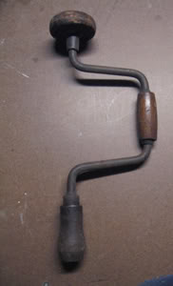
Some very old tools I inherited from my grandfather such as drawknives (a bit rusty but still sharp), and a large chisel:
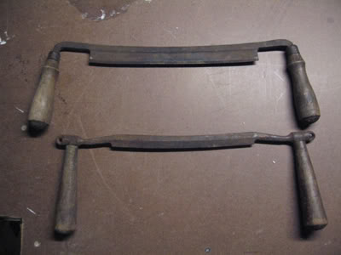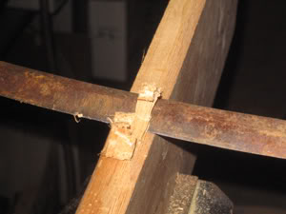
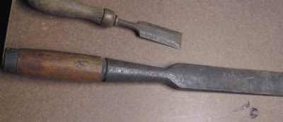

- Quote
- Edit
- Options

Silver
- Plunderer
- Member

- 347 posts
- Gender:Male
- Location:Virginia Beach, Virginia
- Interests:Maritime history
(IP: 24.253.129.208) · ·
Posted April 3, 2008 · Report post
you can still buy spoon bits for your brace. they are now called chair maker bits. i googled up a few sites the other day

- Quote
- Edit
- Options

Dutchman
- Has anyone seen my cousin?
- Admin

- 1,773 posts
- Gender:Male
- Location:tidewater virginia
(IP: 198.246.136.35) · ·
Posted April 3, 2008 · Report post
littleneck,
did not mean to disregard your post- sorry. i will take it to the gf's this weekend and get her to do it as i am a bit technically challenged.
the brace looks like the drawing hurricane posted. the bit is placed with a screw and tapered slot. there is no rotating handle in the middle-solid wood. and is a straight shaft where the pad on the top is. it has metal supports on the sides at the top and bottom to support the angles.

